Lonely Domino
Start with all the dominoes face up. Choose one domino and announce that is lonely and wants to join up with one or more dominoes whose number of dots total up to eight. Once the child has found an appropriate domino or pile of dominoes, place them next to the first domino and announce that the new domino (or pile of dominoes) is lonely and wants to find one or more friends with dots totaling up to twelve. Keep naming off different numbers, occasionally repeating numbers so that the child can see that there are more than one way to create the appropriate number. Keep an eye on which dominos are left and which numbers can be formed.

Domino War
Play just like the card game war, but flipping dominoes instead of cards. Encourage the child to guess who has the higher number before naming the number. You can both flip one domino, or you can flip two at a time adding them together before comparing the total with the other player’s. You can also incorporate subtraction into the game. Flip a single domino and subtract the smaller side from the larger side before comparing the difference with your opponent’s.

Which is missing?
Take two dominoes. Announce the total number of dots and then show the child one of the dominoes. Ask how many dots must be on the other domino. Then let the child have a turn taking two, totaling them and asking you which number must be on the missing dominos. If you can keep it casual enough you can challenge the child to figure out what possible combinations of dots there are that would make up the missing number.

Domino collections
Lay all the dominos out face down. Take turns removing dominos and recording the number of dots. With an older child just use a sheet of paper and count up the dots. With a younger child use an abacus or write the number of dots with tallies – four lines with the fifth going across, and two sets of five per row. Practicing with tallies or an abacus helps the child to recognize ten, twenty, thirty, etc as being groups of tens, and it helps give practice at recognizing patterns like if you have seven (five and two) already out, you need three more to finish up the row of ten.

I’m thinking of a domino that….
Lay all (or a handful) of dominoes face up. Choose which one will be your secret domino but don’t announce it out loud. Give clues such as “one side of the domino has twice the number of dots as the other does” or “the domino has a total number of dots less than 8″ or “one side of the domino has an odd number of dots, the other has an even number.” For each clue, encourage the child to remove all the dominoes that do not meet the criteria.
Then switch players and let the child think up enough clues for you to figure out his or her secret number. The challenge of thinking up clues is a great one.
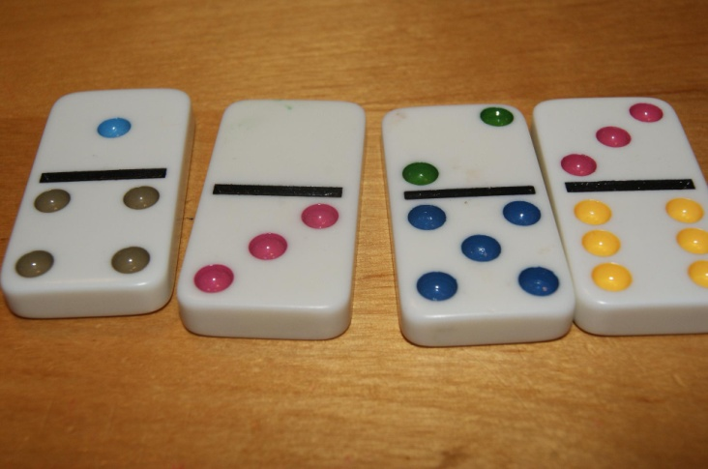

What’s my rule?
Another way to reverse the previous game is to think up a rule and without announcing what the rule and start sorting the dominoes according to that rule. You can allow the child to join in with their guesses or just ask him or her to wait until you’re finished. Then ask the child what they think the rule is? What does your group of dominoes have in common that the others do not have?

Multiplication Dominoes
Multiplication games like Multiplication Dominoes are fun math games that build number sense, mathematical skill, and reduce math anxiety. Scoring each turn focuses on basic facts while keeping a cumulative score keeps addition skills fresh.
Objective: Be the first player to reach 1000 points. (Adjust the target point total as desired to shorten or lengthen the game.)
Recommended Grade Levels: 2, 3, 4, 5
Materials: Set of Domino tiles (Using a double six set focuses on the basic facts through 12. Using a double nine or double twelve set extends practice to double digit multiplication.)
Play: Play dominoes normally following the directions for Basic Domino Game Play using the following rules for keeping score.
Score:
For each play, multiply the total value of the played tile to the total value of the matched tile.
For example, if the (6,4) domino tile is matched to the double six tile as shown, Multiply 12 X 10 for a total score of 120.
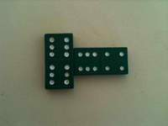
Continue taking turns with each player keeping their own cumulative total score.
When the first player runs out of tiles, subtract the total of the remaining tiles from each players cumulative total. Variation: Subtract the product of the remaining tiles. (Skip the subtraction if the penalty creates drama. Some children find this feels too punitive.)
Winning: The first player to score 1000 points wins.
Tip: If a child is struggling with multiplying numbers, try these ideas:
- Encourage them to group objects/manipulatives and use repeated addition to find the product. (Popsicle or craft sticks and rubber bands make terrific inexpensive manipulatives. Pennies if you keep a penny jar can work well too.)
- Model multiplication using the area of a rectangle and count or add up the squares.
- Skip count to find the product.
- Start with a fact you know and add or subtract to get to the needed product. For example, suppose you need 8 X 9 (think 9 groups of eight), multiply 8 X 10 (think 10 groups of 8, an easy fact you know) first then subtract 8 (think one group of eight). Now you're left with 9 groups of 8, or 8 X 9.
For help in developing a deeper understanding and kids constructing their own knowledge while playing Multiplication Dominoes, I would resist using a times table or calculator. Memorizing the times tables without understanding is not a desirable goal. Kids will memorize the facts with practice, but when they stop using them, they lose the quick recall too. It's more important for them to know what to do when they don't remember than to have all the facts regurgitated quickly. Understanding will serve them throughout their life.

