Facts

|  |
| --- |
|  |
|  |
|  |
|  |
|  |
|  |

Tally

|  |  |  |  |  |
| --- | --- | --- | --- | --- |
|  |  |  |  |  |
|  |  |  |  |  |

Compare

|  |
| --- |
|  |
|  |
|  |
|  |
|  |
|  |

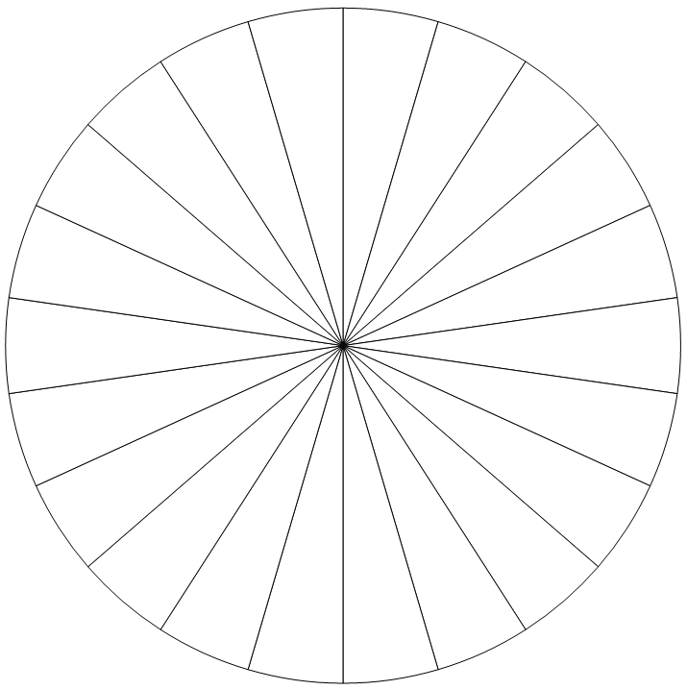Pie Chart